*User Guide*

|  |  |  |
| --- | --- | --- |
| **Supervisor** | Sir.Ubaidullah | |
| **Batch** | 2410c | |
| **Group** | Madam Boutique | |
| **Serial**  **no.** | **Enrollment Number** | **Student**  **Name** |
| 1. | 1616223 | Dakesh |
| 2. | 1613863 | Abdul Ahad |
| 3. | 1616485 | Azam |
| 4. | 1616432 | Sadia |

***User Guide***

MadamBoutique is a stylish and user-friendly online clothing store for men and women. The website features a smooth navigation bar, a dynamic slider, and categorized sections for outfits and collections. Users can explore the latest arrivals with a horizontal sliding effect, view detailed product galleries, and learn about the brand in the About Us section. The Contact Us page provides easy access to customer support with a form, call, email, and location details, including an embedded Google Map. With an intuitive design, MadamBoutique ensures a seamless shopping experience.

***Navigation Bar***

This is the Top of the page.

* User can know about the website by clicking on About Us button.
* Easily navigate through Home, About, Gallery, and Contact sections with our smooth and stylish navbar.

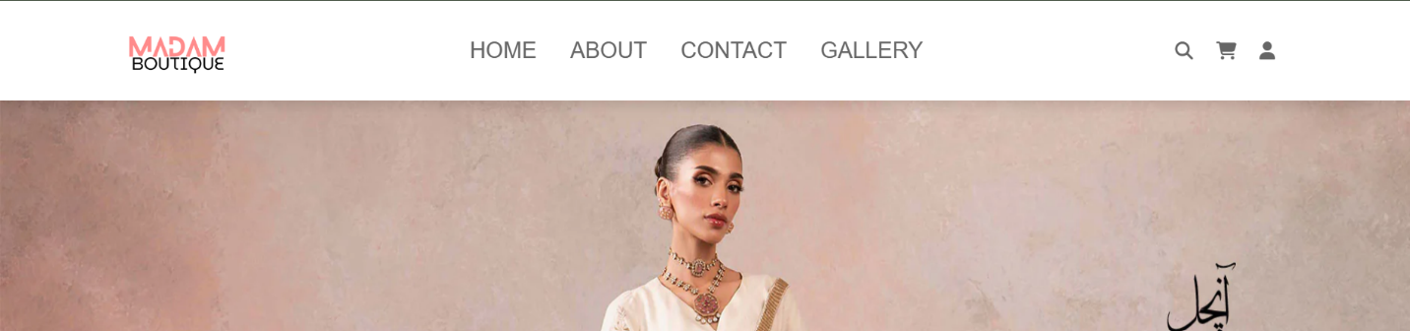

***Home Page***

Discover the latest fashion trends with our stylish and user-friendly homepage.

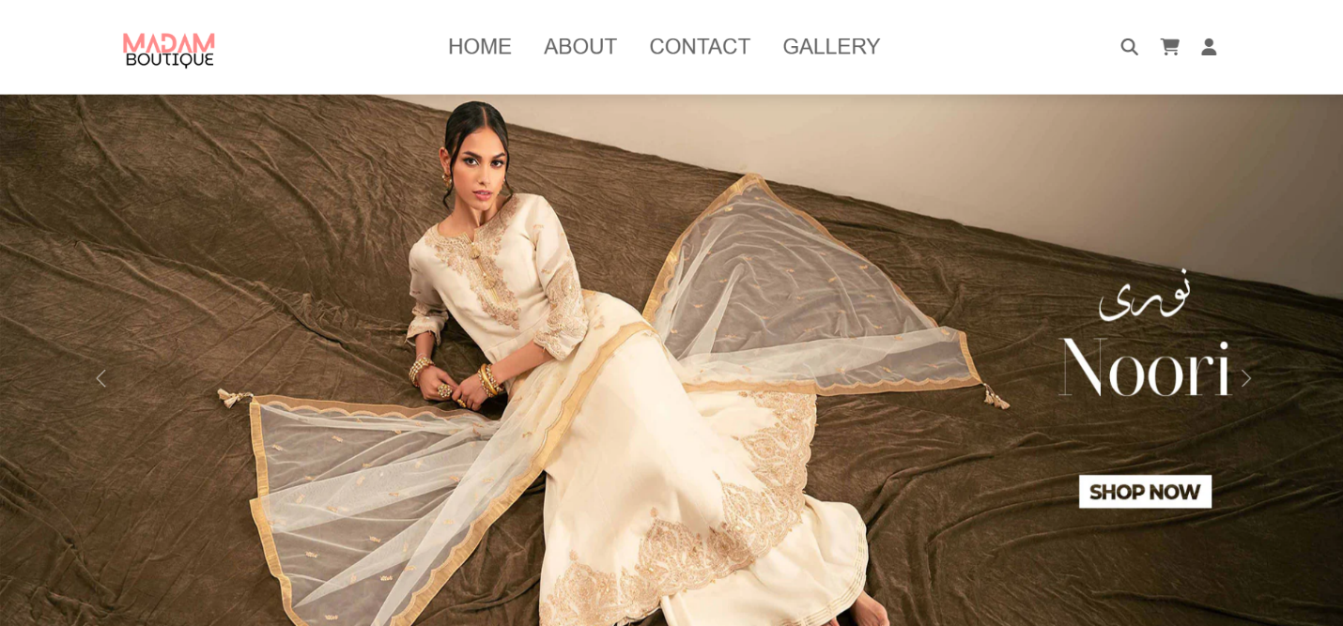

***MADAM BOUTIQUE***

* MadamBoutique is an online fashion store offering stylish outfits for men and women.
* MadamBoutique offers many types of fashion collections, such as casual wear, formal wear, party wear, seasonal outfits, and many more trendy styles.

***Our Latest Product***

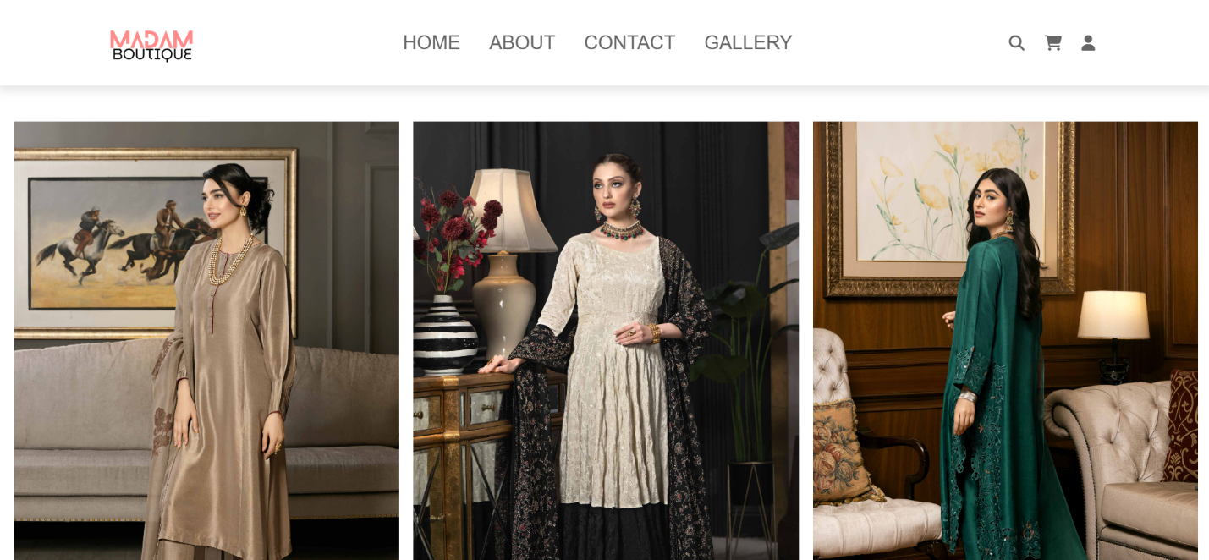

***About Us***

This is the About Us Page.

* This page has some Information about our team and website.

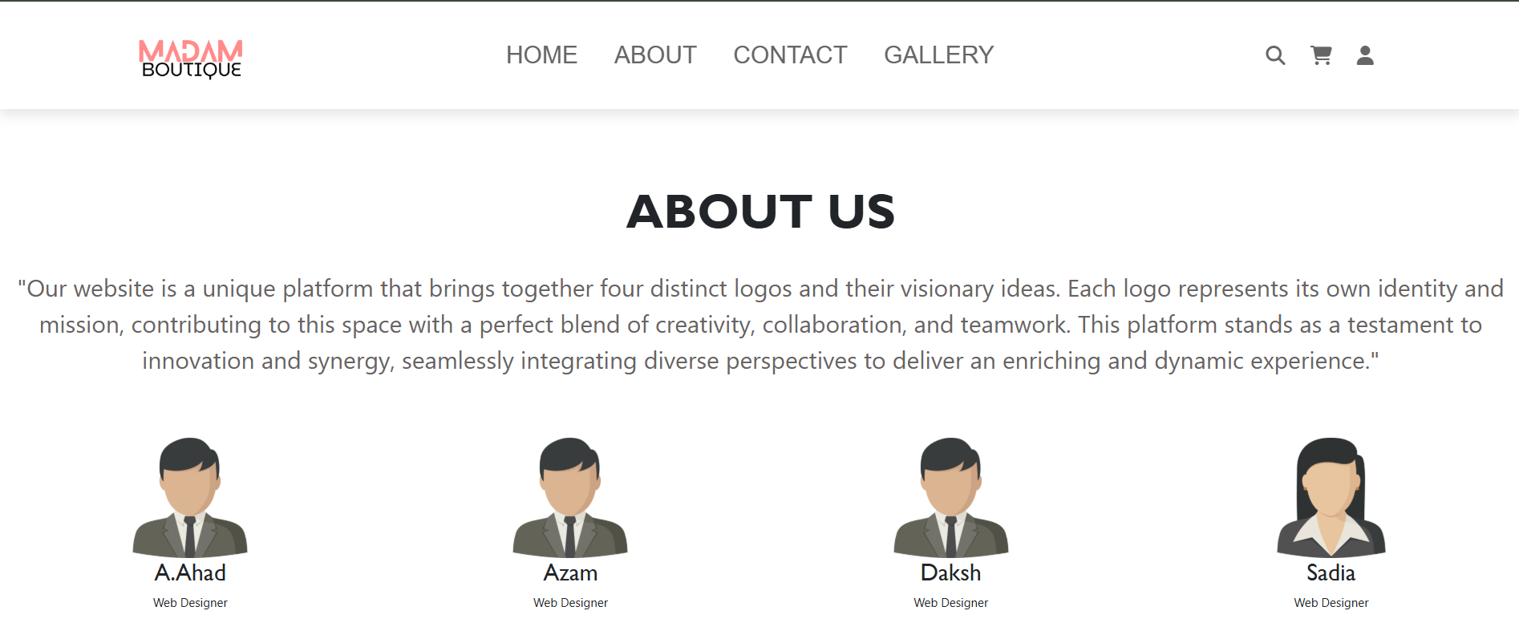

***Contact Us***

This is the Contact us Page.

* In this page users can connect with us.

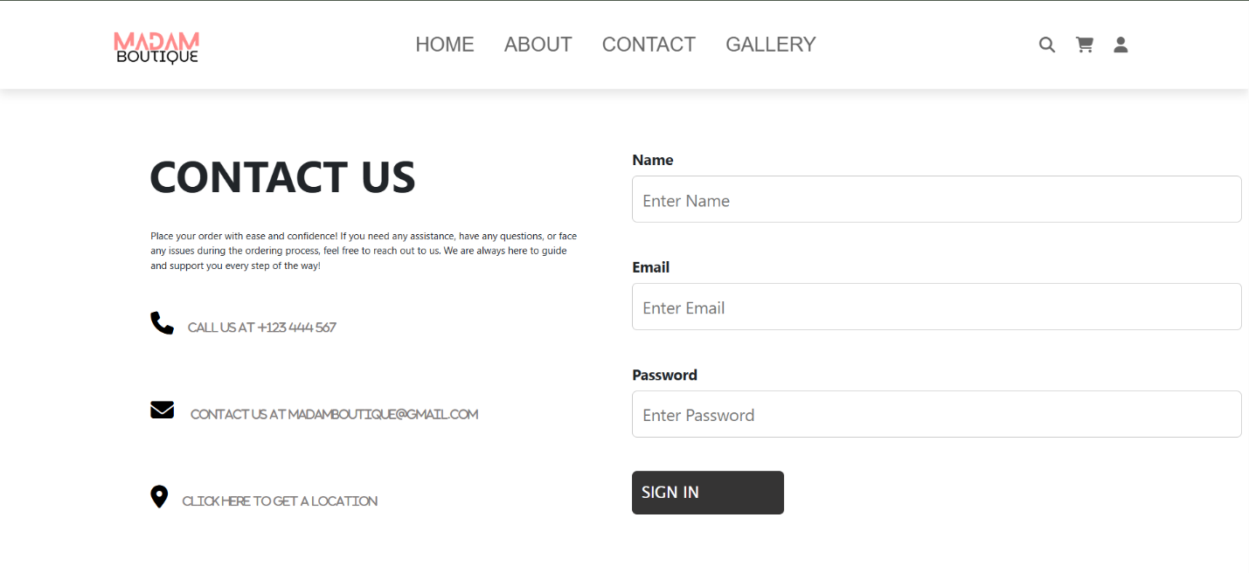

***SIGN UP/SIGN IN***

This is our sign up / sign in page

* Sign in with your email and password to access your account and explore the latest collection.
* Log in to your account to shop your favorite styles and stay updated with new arrivals.

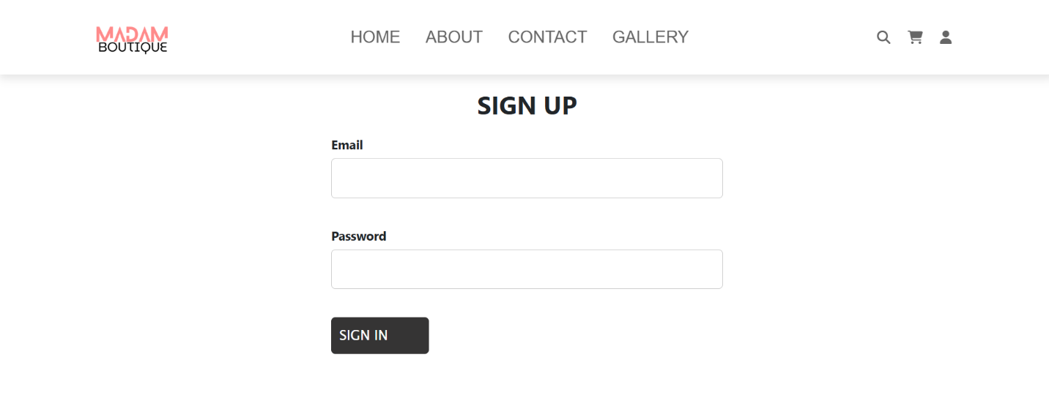

***Footer***

This is the Bottom of the page.

* It has some information of our website and and user also get our info like number,location,address .
* Also users can connect with their emails.

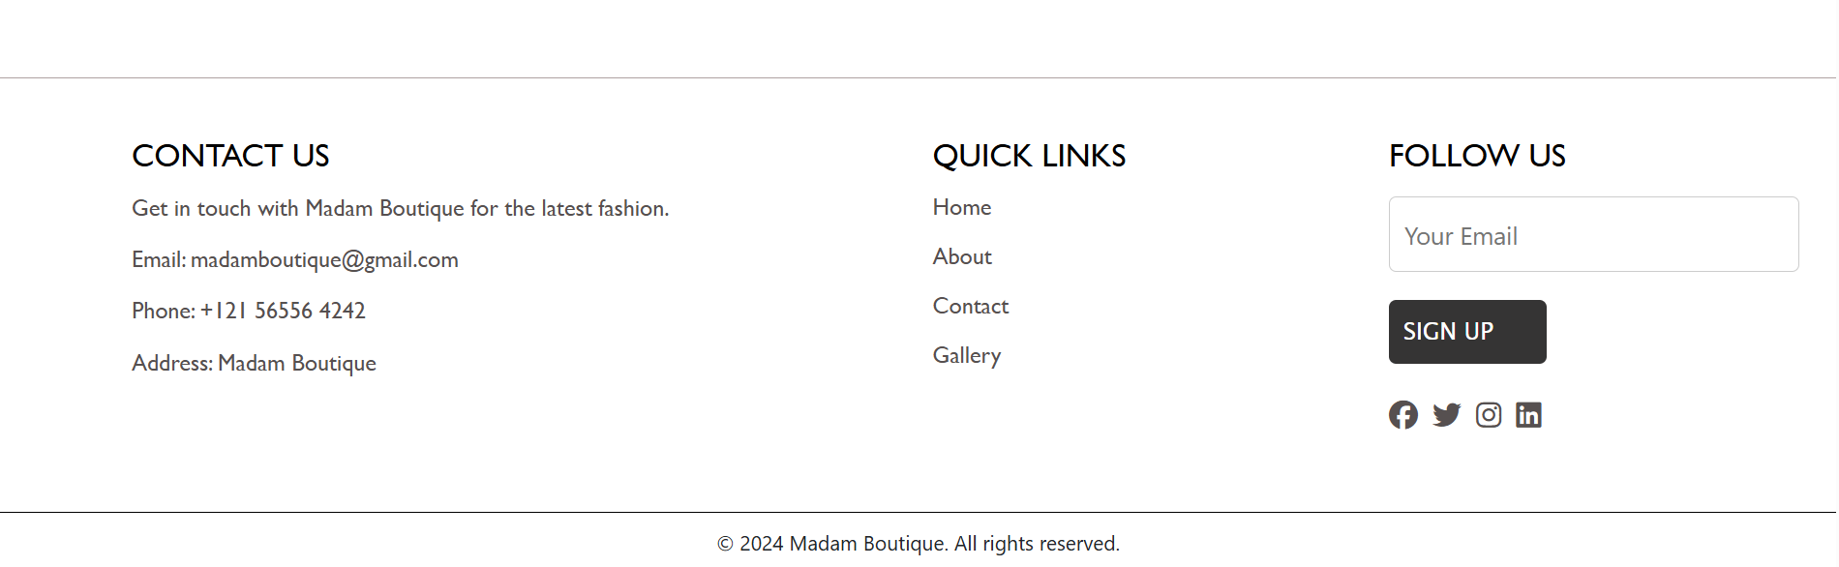

***Thank You For Reading The Documentation****.*